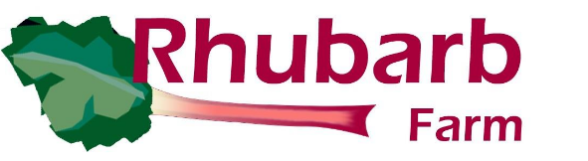
NAME:


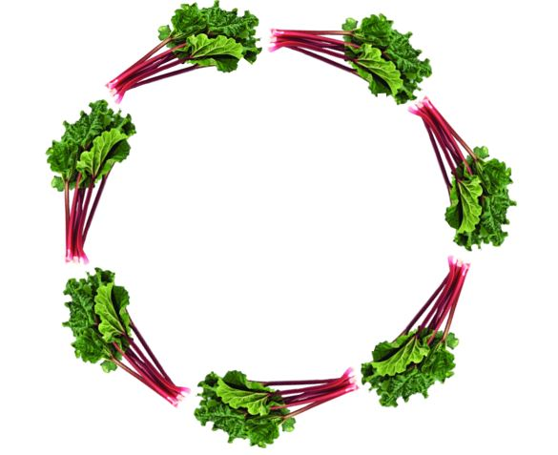
Placement Application

Personal Details
Rhubarb Farm does not discriminate against anyone based upon their sexual orientation, age, gender, race, religion, beliefs, disability, or how you choose to identify. If you have any worries or concerns, please let us know below.

Full Name:
Sex at birth:
Gender (if different):
Preferred Pronouns:
Anything else that you would like us to know about your gender identity:
Date of Birth:
Address:
Postcode:
Living Arrangements:
Telephone number:
Email Address:
Preferred method of contact:
Phone/Text/Email
National Insurance Number:

Benefits
Are you currently getting any benefits that entitle you to a personalised budget?
Yes
No

If yes, please state below which benefit you are getting?

………………………………………………………………………………………………………………

If you are getting any benefits that include a personalised budget, this may mean that you require some form of support whilst at the Farm. Supported Placements incur a fee, and this is something we will need to discuss, and agree, before your start date.

White (English) - Welsh, Northern Irish or British
White – Irish
White – Other
White and Black – Caribbean
White and Black – African
White and Asian
Any other mixed or multiple ethic background
Asian/Asian British – Indian
Asian/Asian British – Pakistani
Asian/Asian British – Bangladeshi
Asian/Asian British – Chinese
Any other Asian background
Black/Black British – African
Black/Black British – Caribbean
Any other Black/Black British background
Arab
Any other ethnic group:
Ethnicity – (please tick)

Emergency contacts
First point of contact
Name:
Telephone:
Email:
Relationship:
Second point of contact
Name:
Telephone:
Email:
Relationship:

Medical Information
GP & Practice Name:
Practice Address:
Telephone:
Pre-existing medical conditions including any mental health illnesses:
Current medications:
(Must be able to self-medicate)
Any known allergies:
Any other medical information you would like us to be aware of:

Additional information
Rhubarb Farm has several projects and programmes designed to help individuals facing difficulties and barriers. Please tick all statements that apply so that you can be assigned to the most relevant project and be introduced to the most appropriate project leader on your first day.
Statement | Yes/No
I have a learning disability/difficulty
I have a physical disability
I live with mental ill health
I am neurodivergent e.g., living with ASD, ADHD
I currently use drugs and/or alcohol
I am in recovery from addiction
I am an offender / ex-offender*
*If yes, please provide details of offence
I will be completing unpaid hours at Rhubarb Farm by order of The Probation service
I have unspent convictions / I am on licence
I have been a victim of crime

Your Referral
At Rhubarb Farm, many of our volunteers are referred through a number of agencies. If you have been referred to the Farm, please complete the details below:
Name of referrer (if applicable):
Agency:
Address:
Telephone number:
Email address:
Date of referral:

Agencies
Are you currently involved with any other agency? (please tick and state which agency)
Type of Agency | Yes / No | Details
Drug/Alcohol Services
Disability Services Charity
Social Care Education
Training Organisation
Probation
Mental Health Team
Youth Offending Team
Adult Services
Supported Living
Housing/Homeless
College/Further Education
Other (Please state)

Additional Background information
Please use this space to tell us any additional background information that may help us to support you better.

Once you have fully completed this form, please return it to:

enquiries@rhubarbfarm.co.uk

